Guidance Note: Climate resilience

What is climate resilience?
Climate resilience refers to the degree to which the University (people, estate, operations etc) can withstand and recover from weather-related events. The University seeks to appropriately avoid, mitigate and manage short and long-term risks that weather events (and indirect weather-caused events) may have on things that are important to the University. These important things include:
- Campus experience (including health and wellbeing of students, staff, industry partners, visitors and animals under the University’s care)
- Core business
  - Teaching
  - Research
  - Engagement
- Enablers
  - Reputation
  - Financial viability
  - University assets (including owned, leased, managed etc)
  - External assets (e.g. utilities, roads, public transport etc)
  - Ecosystems and the services they provide (clear air, water etc)
Climate resilience activities include:
- Appropriate building, infrastructure and landscaping design, construction and maintenance
- Emergency Management Plans
- Business Continuity Plans
- Insurance
- Information and warnings ahead of, during and after potential weather-related events
There is an opportunity for building and public realm projects to reduce risks through their design and to support emergency management and recovery activities during and after events.

Organisational context
The organisational context for the University’s climate resilience activities related to the built environment include:
- Risk Management Policy, which outlines the University’s approach to risk management and the associated roles and responsibilities
- The University’s Risk Management Framework 2023
- A climate change risk on the University Risk Register, monitored by the University Council Audit and Risk Committee
- Sustainability Plan 2030 priority related to Climate Resilience.
The University also considers climate change risk related to its financial investments. This is not discussed further here because it is not directly relevant to capital projects.

Approaches for projects
Design teams for major refurbishment and new building projects, refurbishments that house business critical activities or high-value contents, and significant public realm projects must follow AS 5334:2013 Climate Change Adaptation for Settlements and Infrastructure. The Standard follows AS/NZS ISO 31000:2009 Risk management— principles and guidelines and guides projects through a qualitative risk assessment process, enabling projects to identify risks that need to be addressed or investigated further (see Detailed risk assessment).
At the time of writing this guidance note, climate change risk assessments have been undertaken for multiple buildings, two whole campuses, and trees at Parkville.
Based on the University’s experience with these assessments, the following are likely to result in higher quality, more useful adaptation plans:
- Get end-user input to understand how facilities will be used and what an acceptable level of disruption is. For example, student accommodation that is intended to house emergency services during a regional emergency event (as is the case at Dookie) will need to be more resilient than student accommodation that can be vacated or suffer disruption during such events.
- Consider risks to people (wellbeing and the activities they undertake), animals (both wild and those under the University’s care), ecosystems, and assets
- Consider how the project can increase the adaptive capacity (ability to cope) for people, animals and ecosystems, including those beyond the project’s immediate boundary
- Define risks in ways that are meaningful for the University’s risk management systems. Note that there are (at least) 3 different risk matrices used within the University:
  - Health and Safety
  - Projects (use this one for climate change risk assessments unless instructed otherwise by the University’s project manager – see later in this document for a copy)
  - Organisational
- Clearly document risks, the design / construction response and the residual risk.
- Document the operational implications of proposed design-stage mitigations. For example, a back-up generator to mitigate loss of power requires fuel and maintenance; similarly an automated flood barrier to mitigate flood risk requires scheduled maintenance.
Clearly document and get University sign-off for any residual risks that require operational risk management to reduce the risk to an acceptable level. Responsibility for any operational activities must be allocated to, and accepted by, a specific team or role within the University. Generic terms such as “UoM facility manager” are not appropriate.
- Undertake detailed risk assessments where appropriate
Further information is provided on some of these points in the following sections.

Increasing adaptive capacity (ability to cope)
Project teams should ask: How can the project increase the adaptive capacity of people (and animals) that in the future will be within or near the project area?
Asking this question promotes living system-centred design and consideration of how the project can also improve the resilience of communities and ecosystems neighbouring the project. Table 1 provides some examples of how adaptive capacity can be conceptualised and increased for staff.
Table 1 – Examples of increasing adaptive capacity
Types of adaptive capacity | Description | Hypothetical examples relevant for the University
Resources | The resources (e.g. financial, technological, service) that people can access. | Provision of high-speed data connection, combined with AV facilities, enabling people to work remotely if their normal working location or their transport mode is impacted or under threat (e.g. from storm, flood, bushfire, extreme heat).  Provide readily accessible water fountains or kitchenettes to help people stay hydrated during hot weather.
Flexibility | The ability for people to do things differently. | Work flexibility that enables working from home or other remote location.  Using lecture-capture so that students can catch up on any lectures they miss due to extreme weather.
Social Organization | The ways in which society is organized to enable cooperation and knowledge sharing. | Co-ordinated plans (e.g. evacuation, emergency management, business continuity) between building occupants and Campus Services
Learning / Knowledge | Capacity to generate and understand new information about impacts and adaptation options. | Notifications and warning systems that alert people of a risk to their location such as a heatwave or thunderstorm asthma forecast.  Capturing best practice adaptation in the University’s building design standards and associated documents.
Agency | The ability of people (individuals and groups) to have free choice in responding to change. | Work/study flexibility that enables working/studying from home or other remote location AND being able to do so in response to a climate extreme.

University’s risk management systems
The University’s risk matrix for capital projects is shown below. University project managers can access the original via the Enterprise Project Management System.
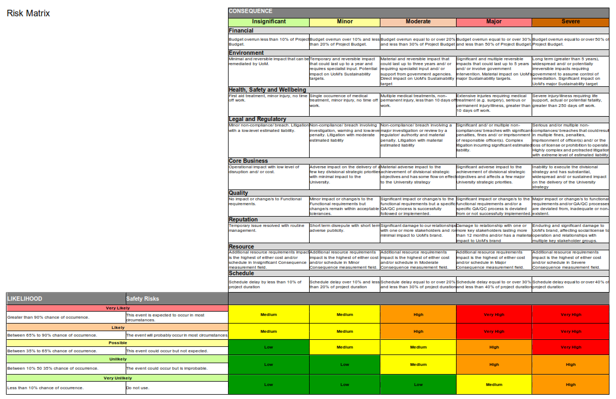
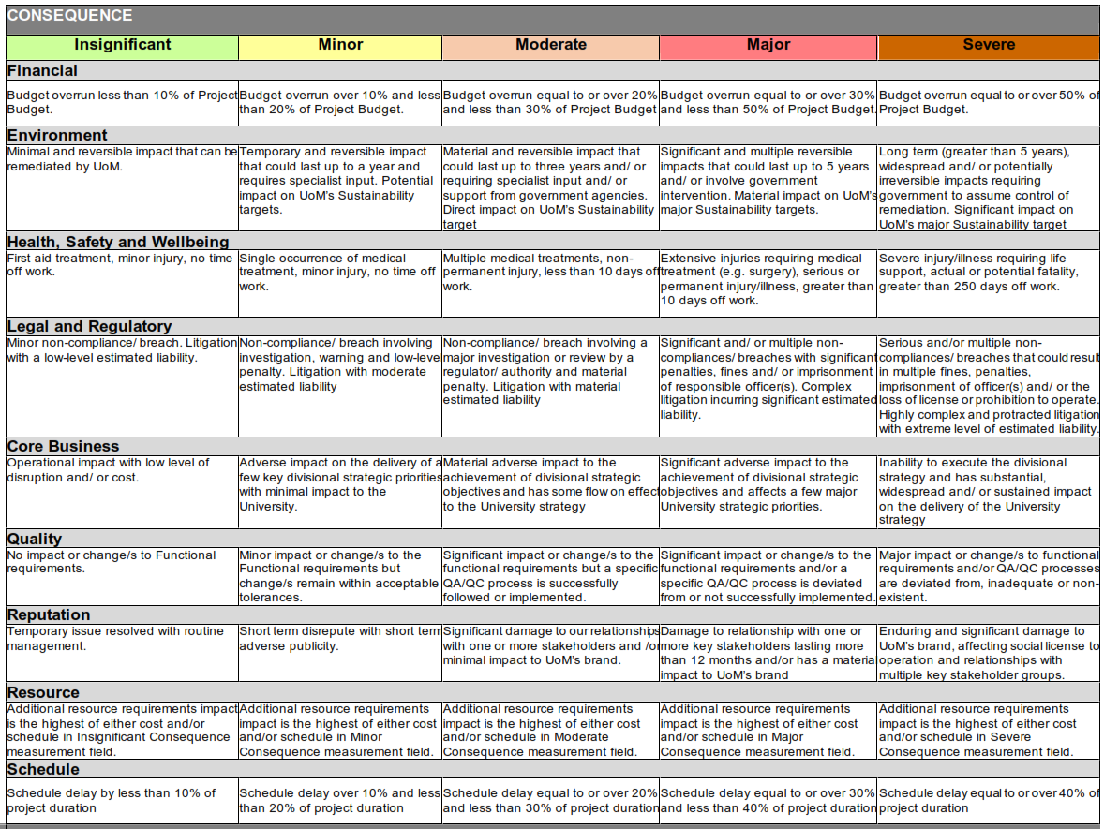
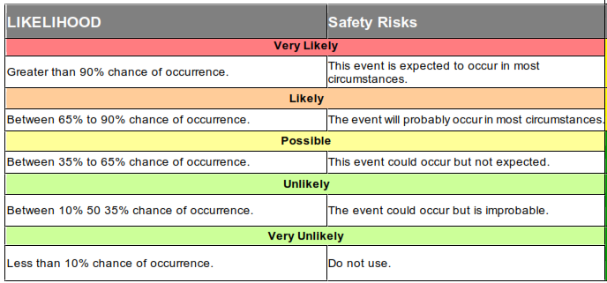

Detailed risk assessment
The qualitative risk assessment may reveal risks that require more detailed assessment because, for example, their acceptability is unclear, they are complex, or the adaptation options require testing. Project teams must appropriately investigate and respond to these risks. Table 3 provides some examples of when this might occur.
Table 3 – Examples of detailed risk assessment and stress-testing
Example | Description
Air-conditioning and natural ventilation design | If a space (e.g. office or dwelling) is designed to be naturally ventilated, then the project team may need to “stress-test” the space to answer questions such as:  - For how many hours per year are internal temperatures likely to cause discomfort?  - Will the internal temperatures become a health risk, e.g. during a heat wave or extreme day?  Note that the annual weather data for Melbourne typically used for energy and thermal comfort modelling has a peak temperature of 39°C. It is therefore inadequate for stress-testing a design under current and future temperatures.
Flooding | Available flood maps from government, water authorities, research, and insurers may be inconsistent (e.g. use different assumptions, suggest different levels of risk for the same location) or limited to the public domain. Detailed review or modelling may be required to understand the actual risk at the project location and the impact of proposed mitigation strategies on neighbours.

http://policy.unimelb.edu.au/MPF1194
https://unimelb.service-now.com/sys_attachment.do?sys_id=a08e7cca1b0efd90d23e64e8b04bcb0d
For example, projects on the east side of the Parkville campus may be able to reduce flood risk to the Melbourne CBD (Elizabeth Street Catchment). Student accommodation at regional campuses is sometimes used as emergency accommodation for people in the area displaced by fire or flood.
The University’s Parkville campus helping to mitigate flooding of the Elizabeth Street Catchment is a good example of improving the resilience of communities.
Adapted from: Cinner et al (2018) Building adaptive capacity to climate change in tropical coastal communities, Nature Climate Change, Vol 8
www2.health.vic.gov.au/public-health/environmental-health/climate-weather-and-public-health/heatwaves-and-extreme-heat/heat-health-alerts
www.emv.vic.gov.au/news/new-thunderstorm-asthma-forecasting-system and www.emv.vic.gov.au/news/vicemergency-app-warning-community-of-risks-in-real-time
Future temperatures can be approximated by using a future climate file for the project location (e.g. https://ahd.csiro.au/other-data/predictive-weather-files-for-building-energy-modelling/)

