Social Model of Disability: 40 years on: Reflecting on progress and challenges

Welcome to the first event in the University of Melbourne’ s Critical Disability Studies Seminar Series

Program: 1 September 2025

3:00pm: Seminar begins
3:00–3:05pm: Acknowledgement of country and welcome
3:05–3:15pm: Introduction
3:15–3:25pm: Keynote (recorded)
3:25–4:00pm: Panel discussion
4:00–4:15pm: Audience Q&A
4:15–5:30pm: Reception with refreshments provided by the Asylum Seeker Resource Centre, Kenneth Myer Building foyer

Chair
Professor Anne Kavanagh is Chair in Disability and Health at the Melbourne School of Population and Global Health, University of Melbourne and Director of the Research Alliance in Youth Disability & Mental Health. Learn more: go.unimelb.edu.au/kw9p

Speakers

Professor Tom Shakespeare is a disability academic, advocate and activist from the London School of Hygiene and Tropical Medicine. He has recorded a special message for this event featuring his thoughts on the social model of disability. Learn more: go.unimelb.edu.au/aw9p

Scott Avery is Professor of Indigenous Disability Health and Wellbeing in the School of Public Health, University of Technology Sydney. Scott is an Aboriginal man descendant from the Worimi people. Dr Scott (as he prefers to be known) is an educator, researcher and policy adviser on Indigenous cultural approaches for the inclusion of people with disability. He has conducted community-based research and policy, and is the ‘Professor in Residence’ at the First Peoples Disability Network. Learn more: go.unimelb.edu.au/gw9p

Lorna Hallahan is an Associate Professor at Flinders University, and has been a social worker for more than 35 years. She has also been a tireless advocate for people with disability for more than 25 years, strategically pushing for change across disability policy, adoption law, and workers' rights across human and health services. In 2019, Lorna was appointed National Research Director for the Royal Commission into Violence, Abuse, Neglect and Exploitation of People with Disability to set up the Commission’s research framework. She has an extensive background in social work practice and leadership. Learn more: go.unimelb.edu.au/9w9p

Ask the panel a question

We are taking audience questions in Slido. Please scan the QR code below to access the app. If you have any difficulties, please grab one of our staff to help.

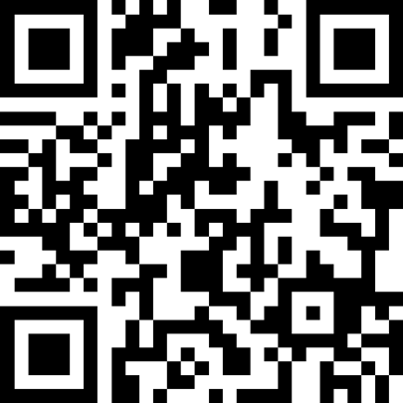

You can also access Slido here

Resources on the day

Professional live captioning for today's session can be viewed within Zoom by clicking 'CC' or 'Show Subtitles' , or via this browser URL (using Chrome, Safari or Firefox): go.unimelb.edu.au/ob9p

Alternatively, scan the QR code:
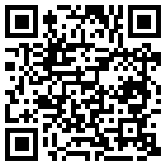

Wi-fi access
Join the University of Melbourne’s Visitor Network:

Username: guest3
Password: 4k$Lq9

For information about the University’s wi-fi policy and terms of use, visit go.unimelb.edu.au/a79p

References
Professor Tom Shakespeare refers to notable academics and activists in his video address. In order of mention, they include:

Union of Physically Impaired Against Segregation (UPIAS)
UPIAS was formed in the UK in the 1970s to advocate for the end of segregation for people with physical disability and for their full inclusion in all aspects of society.

Antonio Gramsci (1891 – 1937)
Antonio Gramsci was an Italian philosopher, political theorist and activist. He is best known for his analysis of how dominant groups and classes use culture and institutions to maintain their power and control. Gramsci was imprisoned in 1926 and died in 1937 shortly after release.

Michael Oliver
Michael Oliver was an academic and activist key to the development of the social model of disability. Oliver was one of the first to shift the focus away from a medical view of disability towards a social view, where people are disabled by social, cultural and economic barriers. Michael passed away in 2019.

Jenny Morris
Jenny Morris is a feminist writer and researcher. Her work has explored extensively the way disability and gender intersect. She is the author of the influential book Pride Against Prejudice. In this book she draws on both her own and others’ experience of disability, confronting the nature of prejudice in contemporary society.

Liz Crow
Liz Crow is a UK-based artist and activist who works across performance, film, audio and text. She is perhaps best known for the film installation “Resistance” which explored Aktion T4, the Nazi program of mass murder that targeted people with disability. Her work has been shown at the Tate Modern and the Kennedy Centre for the Performing Arts.

Emeritus Professor Carol Thomas
Carol Thomas was a Professor of Sociology specialising in disability studies and the sociology of health and illness. One of the pioneers of disability studies, Carol is best known for her two books, Female Forms: Experiencing and Understanding Disability (1999) and Sociologies of Disability and Illness: Contested Ideas in Disability Studies and Medical Sociology (2007). Carol passed away in 2022.

About the next event in the Critical Disability Studies Series

This seminar series was developed in conjunction with the Melbourne Disability Institute and the Office of the Provost, Diversity & Inclusion team, at the University of Melbourne.

Seminar 2: The Disability Discrimination Act: Opportunities and limitations
Monday 20 October

Visit the website or scan the QR code below for more information: go.unimelb.edu.au/uj5p

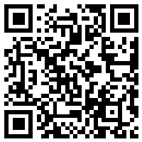

“The social model tells us how we are disabled by society – and we often are – however where is agency? Where is the possibility of disabled people making their own stories and their own identities? Making our own way in the world? Because we do.” – Professor Tom Shakespeare

